Overview

Team Members:

- Aswin Vasudevan
- Sanjana Iyer
- Amogh Katwe

Mission:

Building an Android based Mobile tool for project management. Smart phones have already started replacing the traditional web based and desktop based systems so it becomes an obvious necessity to have application in smartphone with which you can manage the project.

Description:

An Android based mobile application for project management. The tool will aid towards planning and execution of the project where we can track its progress. The app will also help in creating the list of tasks and assigning the tasks to each team members with timeline. The tasks can be further visualized in graphical manner to provide vivid understanding of the project flow.

Key Functions:

- Login: Users can use their Facebook to login to the application. The login page will also be encryption protected since they are taken to standard logins such as Fb.
- Permissions: All the projects that are created in the app gives complete user permission for them to create and visualize the tasks. It is an open source project.
- Project Management: It will allow the users to create and provide the revenue and time details of the project.
- Data Representation: The revenue percentage and pert time data will be graphical represented.
- Data Storage: The app will be available to use all days and since the storage is in app there wouldn’t be any maintenance issues frequently.
- Compatibility: The application is built on recent version of android and will be supported in all the android based devices irrespective of the brand.

Impact of the Project:

1. It is an open source project and it will be handy if a person is at a remote location.

2. Everything is mobile based and android is a widespread used OS which works as USP for our application.

Summary

Scope Statement

Project Title: Mobile Project Manager
Date: Oct 12, 2017 Prepared by: AswinVasudevan,aswinv@bu.edu
Sanjana Iyer, skiyer@bu.edu
Amogh Katwe, amogh@bu.edu

Project Justification:
The motivation of the project is towards building an Android based Mobile tool for project management. Smart phones have already started replacing the traditional web based and desktop based systems so it becomes an obvious necessity to have application in smartphone with which you can manage the project.

Product Characteristics and Requirements:

1. Tools: Android Studio is the IDE we are using to build the application and it’s a native app wherein the user view is designed in the Android UI. The storage for the project is maintained in app to provide ease of access and overcome privacy issues for sensitive projects.
2. User submissions: Users can use their Fb or Gmail to login to the application. They can create the tasks for the project and allocate time to it. Then based on time, they can visualize the project progress in graphical manner.
3. Permissions: All the projects that are created in the app gives complete user permission for them to create and visualize the tasks. It is an open source project.
4. User Requests: The users can further request and view the tasks they have already created and also have the permission to visualize them as graphs.
5. Links: The external links are when the user uses their Fb or Gmail to login they are taken to their sites for authorization.
6. The “Graph View” feature will be very user engaging wherein they can see their progress in one button click. The app also allows them to modify the time and details of the project and again visualize the updated metrics.
7. Security: The app will adhere to all the security standards that are built in from the android environment. The login page will also be encryption protected since they are taken to standard logins such as Fb or Gmail.
8. Project Manager: This feature will allow the users to create and provide the details of the project. The details such as individuals and time factors become crucial for graph building.
9. The application is built on recent version of android and will be supported in all the android based devices irrespective of the brand.
10. The app will be available to use all days and since the storage is in app there wouldn’t be any maintenance issues frequently.

Summary of Project Deliverables
Project management App deliverables: business case, charter, team contract, scope statement, WBS, schedule, cost baseline, status reports, final project presentation, final project report, lessons-learned report, and any other documents required to manage the project.
Product-related deliverables:
1. Survey: Survey of the existing project management tools both web based and mobile based. They are analyzed based on their features and cost parameters.
2. Application: The project team will be providing fully functional android application.
3. User Guide: The project will provide the user document that discuss about how to use the application and we also explain the user how the data is stored and managed.
4. Example Project: There will be one already created project in the application which makes it easy for the user to understand how the app works. 5. Links: The links regarding the in-app storage of data and security for logging in will be provided.
6. Graph Visualization: The App will provide native and third-party Graph API within the app that are used for visualization.
7. App design: The app design will provide ease of access to the user and keep it to the point that the user can navigate between the screens with one touch.
8. App content: The app will provide User interface buttons and other related texts in the app that can guide the users better towards an engaging usage.
9. Test plan: The test plan will document how the application will be tested, who will do the testing, and how bugs will be reported.
10. Open sourcing the project: The project will be available in GitHub from where we target crowd sourcing and open programmers to improve the application.
11. Project benefit measurement plan: A project benefit plan will measure the financial value of the application.

Project Priorities:

- Specification
- Process
- Non Recurring Costs
- Resource Constraints
- Schedule
- Technical Performance
- Recurring Costs

WBS:

Level 1 | Level 2 | Level 3
1 Widget Management System | 1.1 Initiation | 1.1.1 Evaluation & Recommendations  1.1.2 Develop Project Charter  1.1.3 Deliverable: Submit Project Charter  1.1.4 Project Sponsor Reviews Project Charter  1.1.5 Project Charter Signed/Approved
1 Widget Management System | 1.2 Planning | 1.2.1 Create Preliminary Scope Statement  1.2.2 Determine Project Team  1.2.3 Project Team Kickoff Meeting  1.2.4 Develop Project Plan  1.2.5 Submit Project Plan  1.2.6 Milestone: Project Plan Approval
1 Widget Management System | 1.3 Execution | 1.3.1 Project Kickoff Meeting  1.3.2 Verify & Validate User Requirements  1.3.3 Design System  1.3.4 Procure Hardware/Software  1.3.5 Install Development System  1.3.6 Testing Phase  1.3.7 Install Live System  1.3.8 User Training  1.3.9 Go Live
1 Widget Management System | 1.4 Control | 1.4.1 Project Management  1.4.2 Project Status Meetings  1.4.3 Risk Management  1.4.4 Update Project Management Plan
1 Widget Management System | 1.5 Closeout | 1.5.1 Audit Procurement  1.5.2 Document Lessons Learned  1.5.3 Update Files/Records  1.5.4 Gain Formal Acceptance  1.5.5 Archive Files/Documents

Critical Path

Tasks | Optimistic duration | Most likely | Pessimistic duration | PERT weighted average | Variance
Testing code | 15 | 20 | 25 | 20 | 2.777777778
Deploy and Maintain | 10 | 15 | 20 | 15 | 2.777777778
SUM | 25 | 35 | 45 | 35 | 5.555555556

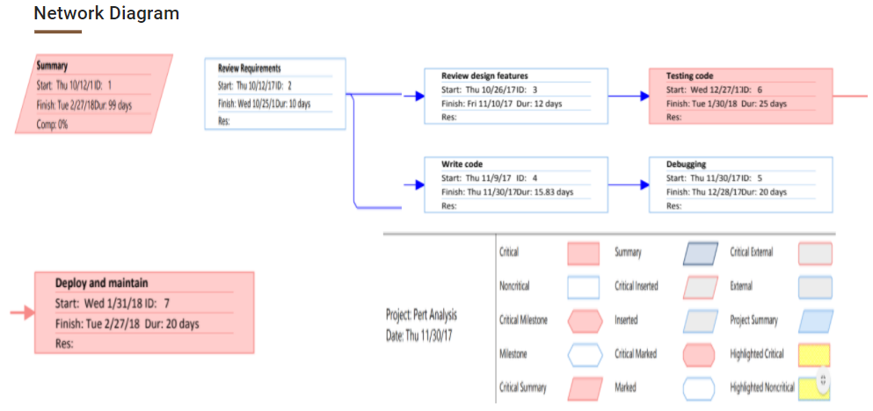

Responsibility Matrix

WBS | OBS
Survey of existing applications | Sanjana Iyer
User requirements | Sanjana Iyer
UI design | Amogh Katwe
Implementation | Aswin Vasudevan
Testing & Risk management | Amogh Katwe
Deploy and maintenance | Aswin Vasudevan

Cost-Time phased Graph
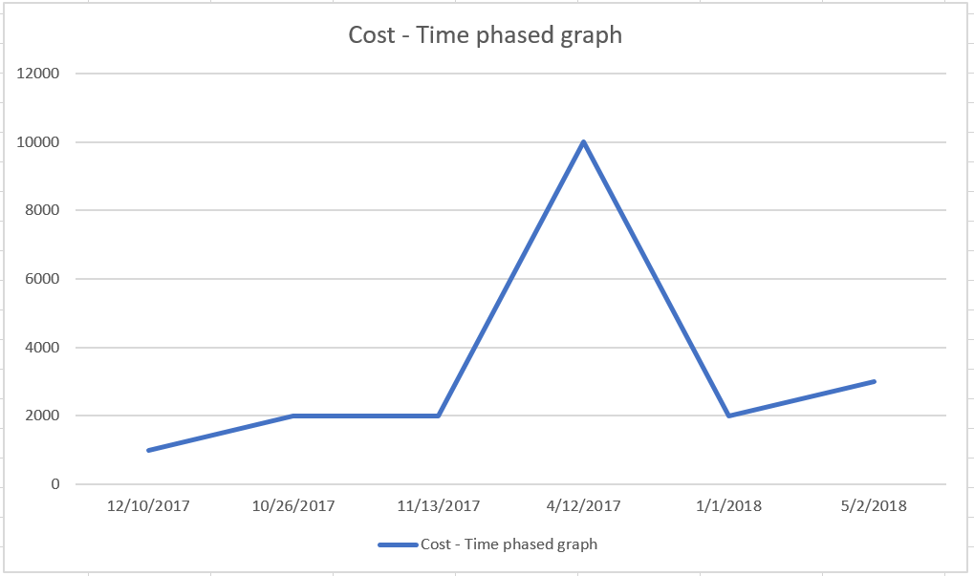

Gantt Chart: Slack
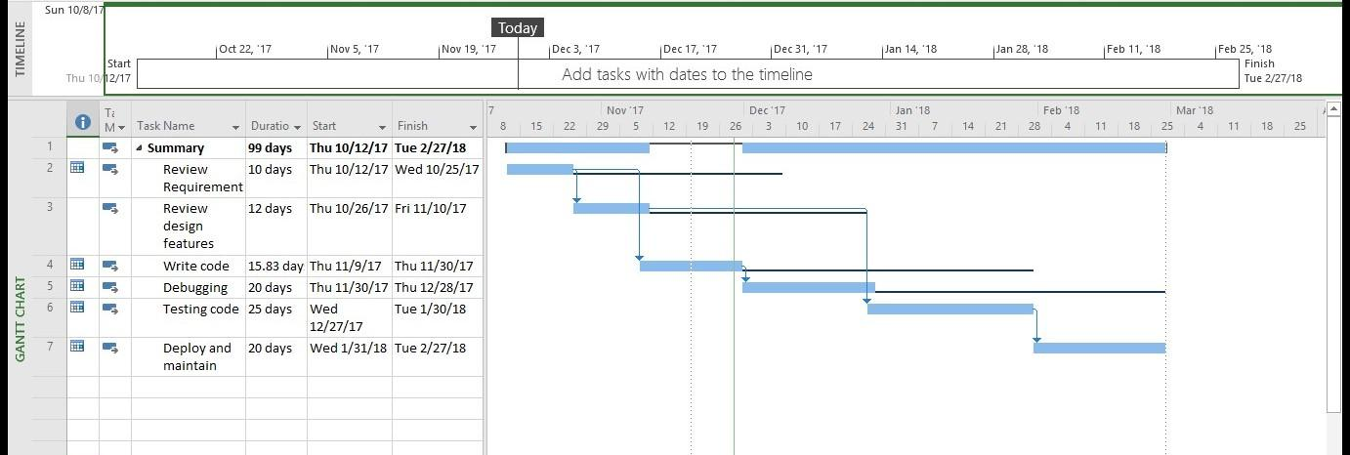

Conclusion

1. The issue with the application is FB login is restricted to 100 logins in a day span.
2. The solution to this problem is recovery time should be more and testing should be done in less than 100 logins.

